Calculator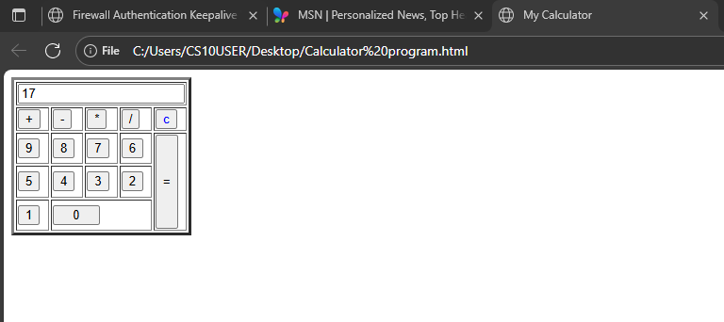
<!DOCTYPE html>
<html>
<Head>
<title> My Calculator</title>

<script>
function appendVal(x)
{
y=document.getElementById('total').value;
document.getElementById('total').value=y + x;
}
function calculate()
{
x=document.getElementById('total').value;
document.getElementById('total').value =eval(x);
}
</script>
</Head>

<table border="3">
<tr>
<td colspan="5"><input type="text" id="total"></td>
</tr>

<tr>
<td ><input type="button" value="+" onclick="appendVal('+')"></td>
<td ><input type="button" value="-"onclick="appendVal('-')"></td>
<td ><input type="button" value="*"onclick="appendVal('*')"></td>
<td ><input type="button" value="/"onclick="appendVal('/')"></td>
<td ><input type="button" value="c" style="color:blue;"></td>

</tr>
<tr>
<td ><input type="button" value="9"onclick="appendVal('9')"></td>
<td ><input type="button" value="8"onclick="appendVal('8')"></td>
<td ><input type="button" value="7"onclick="appendVal('7')"></td>
<td><input type="button" value="6"onclick="appendVal('6')"></td>
<td rowspan="3"><input type="button" value="=" style="height:100px;"onClick="calculate()"></td>
</tr>
<tr>
<td ><input type="button" value="5"onclick="appendVal('5')"></td>
<td ><input type="button" value="4"onclick="appendVal('4')"></td>
<td ><input type="button" value="3"onclick="appendVal('3')"></td>
<td ><input type="button" value="2"onclick="appendVal('2')"></td>

</tr>
<tr>
<td ><input type="button" value="1"onclick="appendVal('1')"></td>
<td colspan="3"><input type="button" value="0" style="width: 50px;"onclick="appendVal('0')"></td>
</tr>
</table>
</html>

